Newsletter December 2013.
We hope you are all well and everything is OK with you and your family.
For various reasons and time restrictions, we were unable to send a Newsletter in July but hopefully this one will make up for it!

It wasn’t a bad summer was it? After the long and awful winter we had last year, we all deserved some sun! Let’s hope that this winter treats us better.

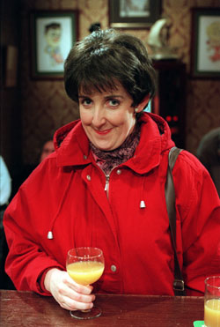
Those of you who watch Coronation Street will know that Hayley Cropper, Roy’s wife at the café has been diagnosed with pancreatic cancer. With something like 8 million viewers, this storyline in a popular TV programme will help to give a terrible and debilitating illness some well needed publicity and hopefully it will prompt anyone with similar symptoms to see their doctor pronto. Time is of the essence with this awful cancer. See our website (Home page under “Blog update”) for Symptoms of Pancreatic Cancer. Julie Hesmondhaigh as Hayley.

With recent comment in the press about “charity fat cats”, it is worth reiterating that none of our Fund’s Trustees receive any remuneration and do not reclaim expenses. Some 92% of all our donations go on charitable causes and if we exclude fundraising expenses, the ratio jumps to 96%. We’re proud of this and this is the way it’s going to stay.

So what have we been doing? Our research work has continued unabated!

At St George’s University of London, Dr Androulla Elia and her colleagues have been working for the past few years on research into how a naturally occurring human hormone-like chemical can be targeted to kill pancreatic cancer cells, without damage to healthy cells, especially when combined with other drugs. This research has now been accepted for publication in the respected scientific journal “Biology of the Cell”, which is a significant step forward in getting the research “recognised”. As Androulla puts it, this achievement would not have been without the support of the donors to our Fund.
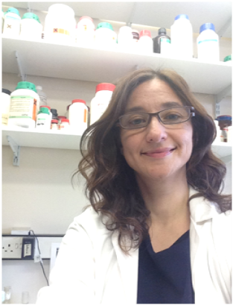
Alongside this on-going project, Androulla’s research is also focusing on how the human immune system can be adjusted to respond effectively to tumour cells by using a therapy which is currently being tested in a clinical trial (see next paragraph) of pancreatic cancer. This exciting aspect of Androulla’s work is in collaboration with a small
pharmaceutical company, Immodulon, and the laboratory of Dr Thorsten Hagemann at Bart’s
Cancer Institute. The team is confident this work will strengthen the understanding of how immune cells can play an important role in
fighting pancreatic and other cancers.

Here’s Androulla at St George’s.

Clinical trials are sets of tests in medical research and drug development that generate safety data and information about adverse drug reactions. They are conducted only after satisfactory information has been gathered on the quality of the non-clinical data and health authority/ethics committee approval must be granted before clinical trials are carried out. This approval is, quite correctly, not given lightly and the fact that our research has been granted this facility is another major step forward.

And elsewhere at St. George’s, the research team under Professor Gus Dalgleish is
continuing research into how cancerous cells become resistant to a drug called “gemcitabine”, which is considered the “gold standard” when treating pancreatic cancer and also into how that resistance can be overcome. Recently there have been some rewarding developments.
Some cancer patients acquire a resistance to gemcitabine after prolonged treatment whilst others have a natural resistance to it, for reasons which are not currently understood. Laboratory trials have shown that even in the presence of gemcitabine, new cancerous cells multiply at the same rate as in the parent cancerous cell and can resist cell death and the induction of aging, a process which can render the cell benign.
Without wishing to be too technical, when a cell replicates, it undergoes various checkpoints to make sure the cell is healthy. In a cancer cell, these checkpoints are not regulated correctly which allows the cancerous cell to proliferate. Gemcitabine should reactivate these checkpoints but for some reason this does not happen in some patients. It has been found that some naturally produced proteins found in healthy cells are altered in the cells which are resistant to gemcitabine. The reason for this happening and what causes it is now being researched and hopefully the results of this research will lead to clinical trials.

Additional research into the application of curcumin-the active ingredient of turmeric- has shown that curcumin can cause rapid cancerous cell death as it affects the checkpoints mentioned above at a different stage to that targeted by gemcitabine. This is an important starting point for research into the development of more combinations of drugs.

None of this research produces overnight results and the dedication of all the research teams is very much appreciated.

And what about our supporters? In no particular order………………

Andrew Bolton tells us;
“On 6th June, along with around 4000 other cyclists, Tina and I set off on the Nightrider 2013 ride- a 100km ride around London, and, as the name suggests, it’s at night!
Not being night owls, the challenge was always going to be staying awake for our allotted departure time of 23.10 on the Saturday night from Crystal Palace. But we stayed awake, got there bright eyed and bushy tailed and off we went.
London through the night was a fascinating journey. We cycled through some less salubrious areas where safely was certainly in numbers and passed some of the most iconic buildings that the city has to offer. High points were cycling en masse over Tower Bridge, around Piccadilly Circus, across the "Beatles" zebra crossing on Abbey Road, past Lord's and the Oval and stopping for a photo of Big Ben on Westminster Bridge at 05.00 on the Sunday morning. Looking at the amount of traffic, its London, not New York, which is the city that never sleeps.
Stranger sights included bewildered "partygoers" staggering along, wondering why there were hundreds of Lycra clad cyclists bearing down on them in the early hours and also a barber's shop open and full of customers at 03.00!
Having avoided the temptation to visit late night drinking dens and frequent kebab shops, we finished back at Crystal Palace at about 06.00 on Sunday morning, drove back to Hampshire to grab 40 minutes sleep before getting back in the saddle for another 25 mile sponsored ride around the local countryside - this took a little less time at one hour twenty three minutes!
We raised about £800 in memory of our great friend Jeremy Pritchard and would like to thank the RBPCRF for contributing to our entry fees”.

Many thanks to Andrew and Tina for their support. Hopefully their saddles were comfortable!

We were well supported in the Silverstone Half Marathon, which is run around part of the Silverstone motor racing circuit in Northamptonshire. Sally Bayliss, who ran in 2012 for us, did it again this year in about the same time as before and this year she had her daughter, Victoria, running with her. Victoria beat her mum at about 2 hours 20 minutes but Sally was only an hour behind her. Age makes a big difference doesn’t it? They were running in memory of Sally’s late husband and Victoria’s dad, Simon who was struck down with pancreatic cancer a few years ago.
Thanks again Sally and Victoria. Your support is really appreciated.

And also at Silverstone were Helen Gibbons and her partner Jos Priestley, who ran the half marathon for the first time in memory of Jos’ granddad, Roy, who sadly died from pancreatic cancer in 2012. Helen and Jos now have the “bug” and are planning to again for our Fund if we can secure places in a suitable event. Thanks Helen and Jos for your effort and support.
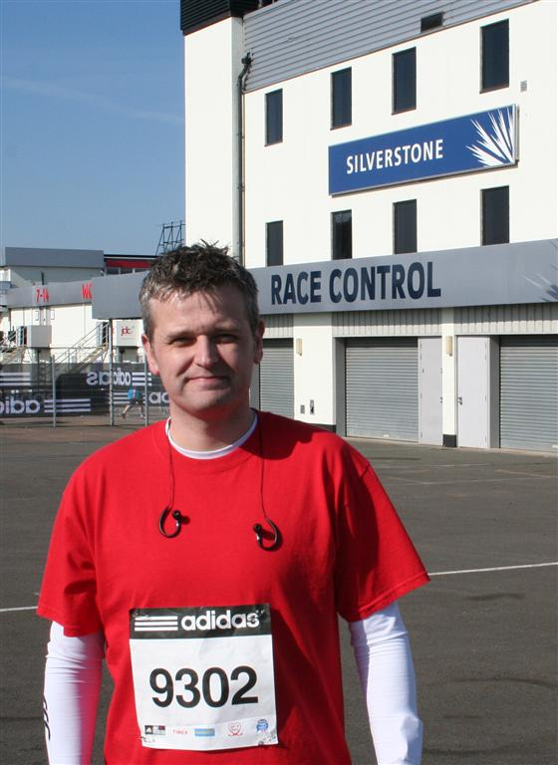

In the London Marathon we had regular donor Stuart Donaldson supporting us. Stuart ran the Silverstone Half
Marathon last year- there’s Stuart on the right at that event.

Thanks Stuart for your continuing support.

And last but not least at Silverstone was William White, whose dad Graeme died from pancreatic cancer in 2005. He managed a time of 1 hour 39 minutes, which is excellent. William also ran in the Virgin London Marathon for our Fund and was due to run in the Edinburgh Half Marathon but unfortunately injury prevented him doing so.
But we were supported in the Edinburgh event by Jonathan Moon, a friend of William’s. Jonathan was due to run in the London Marathon but a football injury ruled him out. William, his mother Sally and the rest of the family and their friends have been regular supporters to our Fund in memory of Graeme and we are extremely grateful for their generous support.

Our Fund is an Affiliated Charity to the Edinburgh Half Marathon event and the organisers also arrange marathons or half marathons in Bournemouth (October), the Kilomathon around Easter time in Edinburgh and the Big Fun Run which takes place in various locations between June and November each year. If you are interested in running for our Fund or know someone who is, let us know by email to lesbiggs@hotmail.co.uk. You can find out more about these events by visiting www.gsi-events.com.

Many and grateful thanks to all of the above and to all those we haven’t mentioned in raising money for us. Apologies to those not mentioned! The Fund could not do what it does without your help and as you know, we do not fritter away your hard earned donations on expensive glossy advertising and mailings. That’s not what your donations are for. This Newsletter is about as glossy as it gets!

STOP PRESS! A BBC TV “Rogue Traders” program has highlighted that a con man is preying on the vulnerable by offering a cure for pancreatic cancer consisting of a useless “light box”. Obviously it doesn’t work but people have been taken in. If you hear of anyone being approached, please warn them!

Seasonal greetings and a healthy and prosperous New Year to all of you and once again, many thanks from all the Trustees.
December 2013.

********************************************************************************
Making a donation. Donations can be made;
- Directly to the Administration address shown on page 1.
- By direct transfer to our bank account at:
HSBC. Sort code; 40-26-07. Account number; 81635190.
Please quote your name as the reference.
- By donating online by credit or debit card with either;
MyDonate at www.mydonate.bt.com or
Justgiving at www.justgiving.com/rbpcr/donate or
Virgin Money Giving at www.virginmoneygiving.com.
They all reclaim Gift Aid for us.
- Leaving a Legacy in your Will. If you want to know more about leaving a legacy, please visit our web site at www.ralphbatespcr.org.uk.
- Gift Aid. If you are a UK tax payer we can claim 25p from HMRC for every £1 you donate. You can download a Gift Aid declaration from our web site but no need to do this if you donate through one of the web sites named above. They will take care of Gift Aid. But note that you must have paid or will pay an amount of Income Tax and/or Capital Gains Tax for each year (6 April to 5 April) that is at least equal to the amount of tax that all the charities or Community Amateur Sports Clubs that you donate to will reclaim on your gifts for that tax year. VAT and Council Tax do not qualify.

